Friday 16 November COMMUNITY MEETING: 7 pm – 9 pm
Money as ‘New Mystery’ facilitated by Chuck Ginsberg
Continuing our discussions on Steiner’s 3-fold Social Organism, we will delve into the economic sphere
For more info. contact Chuck Ginsberg
***
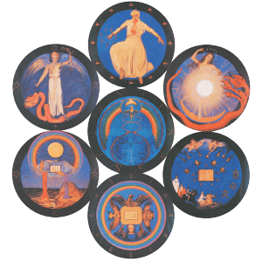
Friday 30 November 2018 – 7 – 9 pm
HIDDEN IN PLAIN SIGHT: THE MYSTERY OF THE APOCALYPSE
with Margaret Shipman
‘Apocalypse’ today almost always means war, but its primary definition is REVELATION. the Book of Revelations seems warlike until we begin to delve into the messages, seals, trumpets and bowls as stages of initiation! We will explore the complexities of this amazing book of the Bible by taking a journey through the 7-pointed star and the Apocalyptic Seals of the 1907 Munich Conference.
For more info. contact Hazel Archer Ginsberg
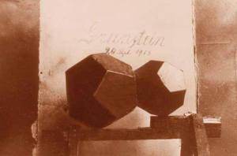
Saturday 1 December 2018 – 10 am – noon
THE CHRISTMAS CONFERENCE
How can we begin to understand the importance of The Christmas Conference of 1923/24? Can it be understood as so profound to consider it a second turning point of time?
We will take a journey with the foundation stone, beginning with the laying of the first stone, a physical one, for the first Goetheanum, in 1913. Then — through the phoenix experience of the 1922/23 fire, and its journey back to earth a year later—we find it again, as a foundation stone meditation planted into our hearts. The introduction of The Foundation Stone Meditation was a central focus of the Christmas Conference week. It was one of three great gifts which Rudolf Steiner brought at this time as powerful spiritual tools for human evolution.
Margaret Shipman has been a member of the Anthroposophical Society for 30 years and considers the work of Rudolf Steiner to be the core of her life. In 2002 she started a national study group for anthroposophy – ‘Geographically Engaged Members Studygroup’, or G.E.M.S. She is also a cellist and pianist and spent 36 years repairing and making instruments of the violin family. She co-authored the book titled Violin Restoration with her mentor, Hans Weisshaar, who was in the second-ever Waldorf class and met Rudolf Steiner as a child.
For more info. contact Hazel Archer Ginsberg
***
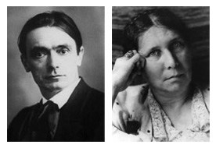
Wed. 5 December 2018 CRC Zoom Call 7:15pm – 8:30pm – Reincarnation & Karma with special guest: Dr. Ross Rentea: “A presentation from the karma and the work together of Rudolf Steiner and Ita Wegman”
Steiner considered I. Wegman a true “friend”, companion over many incarnations, and invaluable helper. In her incarnation in the 20th century she collaborated with him in writing a book, asked decisive questions that led to the Christmas Foundation Conference, the First Class, and more. We will look especially at their working together on the “Fundamentals of Therapy” a work on which R. Steiner put finishing touches until hours before crossing the threshold.
Ross Rentea, MD, has been practicing anthroposophical medicine in Chicago for 35 years. He is a member of the Anthroposophical Society(1972), the First Class of the School for Spiritual Science(1974), the Physicians Association for Anthroposophic Medicine (1984) and the Christian Community (1976). He has served on the Board of the American College of Anthroposophic Medicine. He has lectured nationally and internationally, and published and written numerous scientific research articles and recently (2017) the book “Childhood Illnesses and Immunizations”. Besides anthroposophical medicine his current interests are in better understanding the seven Rhythms of the Foundation Stone. He is a co-founder of the True Botanica Company www.truebotanica.com and the Lili Kolisko Institute for Anthroposophical Medicine www.koliskoinstitute.org .
For more info. contact Hazel Archer Ginsberg
***
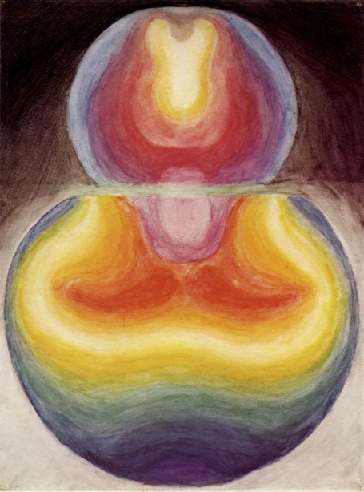
Friday 7 December 2018 Doors open at 6:45pm
Dr. Ross Rentea: “The Rhythms of the Foundation Stone Meditation and Its Connection to the Stars” 7 pm – 9 pm
Rudolf Steiner expresses during the Christmas Conference that these rhythms “should never leave us again”. How can we understand these Rhythms better so that we may truly incorporate them with their high significance into our daily lives? We are being urged in the Foundation Stone Meditation to “practice, practice, practice” how can we do that with the Rhythms?
For more info. contact Hazel Archer Ginsberg
***
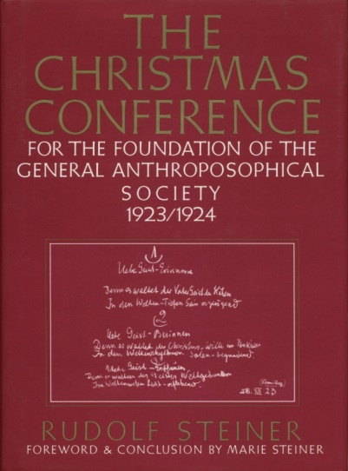
Holy Nights 2018-19

Study: The Christmas Conference –
“World History in the Light of Anthroposophy” The Evening lectures given by Rudolf Steiner

Humanity now stands in the presence of the guardian of the threshold who challenges us to take a step into a new sphere of activity, into the spiritual world. In these lectures, given concurrently with the Christmas Foundation Meeting, Steiner presents a comprehensive survey of the history of the ancient mysteries and the spiritual guidance of humanity. This prepared and strengthened the founding assembly for his courageous, decisive act of establishing the new mysteries during the Christmas Foundation Meeting.

Thursday December 27th –Sunday December 30th
7 pm – 9 pm

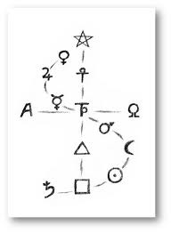

Monday December 31st New Year’s Eve Party
8 pm – 1 am

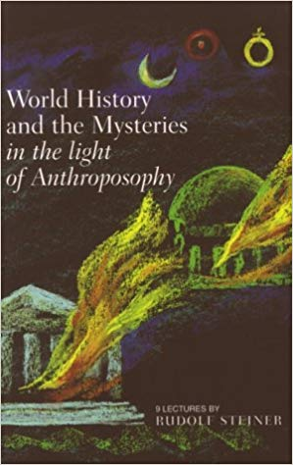
January 1 – Jan. 5th The Christmas Conference Study Continues 7 pm – 9 pm
“World History in the Light of Anthroposophy”
The Evening lectures given by Rudolf Steiner

Copies available in the library or on the archives
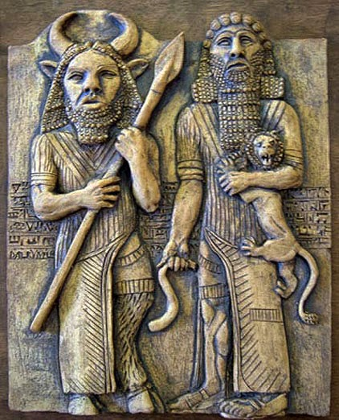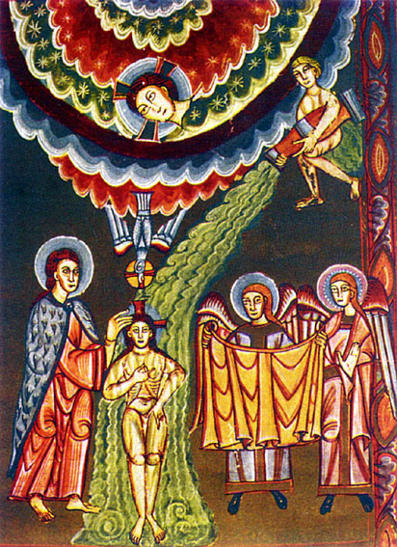
Sunday 6 January 2019 – A Festival of Epiphany:
From Gilgamesh & Eabani to the Baptism in the Jordan
2 pm – 4 pm

For more info. contact Hazel Archer Ginsberg
***
Rudolf Steiner Branch of The Anthroposophical Society,
4249 North Lincoln Avenue. Chicago, IL 60618 (map)
Check out our Web site! (Anthroposophical Society in America)
The Elderberries 3-Fold Space & the Flex Space are available for rental on PEER SPACE for classes, events, meetings, retreats, art exhibits, family parties, etc..

