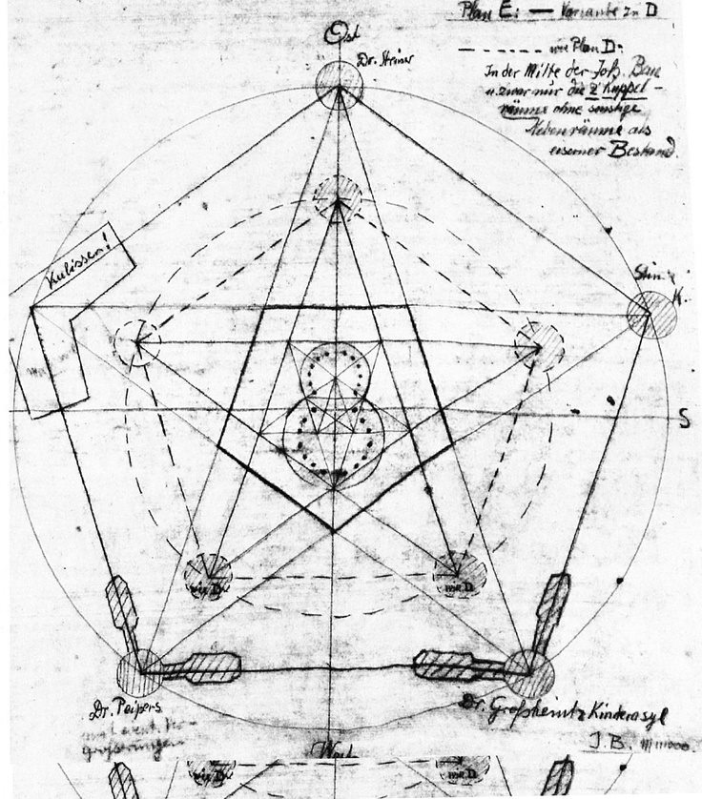

Rudiger Janisch
"The Spiritual Goetheanum, The 3-fold Human Being
& the 3-fold Social Impulse"

7 – 9 pm Friday 13 December 2019
9 am – 12 pm Saturday 14 December 2019
At the Rudolf Steiner Branch 4249 N. Lincoln Ave. Chicago

$50 for the weekend or pay what you will - For more info. contact Hazel hag@RSchicago.org

Rüdiger Janisch has been working in Curative Education and teaching in professional training programs in Germany and the United States for over 40 years. A long-time student of anthroposophy, he serves on the Collegium of the School for Spiritual Science in North America. His contributions to adult education methods were recognized in the context of an international research project sponsored by the European Union. He has been a member of the core faculty of a joint ‘Training for Trainers’ program supporting Curative Education and Social Therapy in Russia, Ukraine, Georgia, and Kyrgyzstan. He has also taught as an adjunct faculty member of the M.S. Ed program in Waldorf Remedial Education at Antioch University N.H. Having taught many different aspects of anthroposophy and Curative Education, he currently is focused on action research and the development of artistic and experiential approaches to the spiritual scientific study of the human being.

